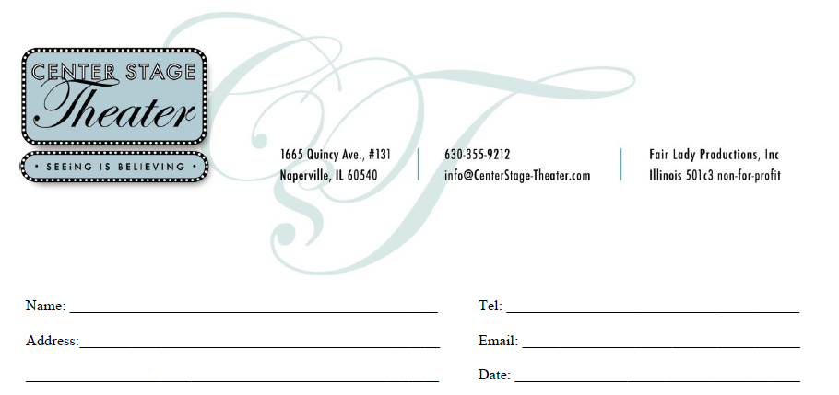

Item | Name on Star | QTY | Unit  Price | Total
Walk of Fame  FAMILY STAR |  | ______ | $300 | ____________
Wall of Fame  KIDZ STAR |  | ______ | $75 | ____________
In lieu of a star, please except my…  DONATION |  |  |  | ____________
For Office Use Only  □ Check#:__________________________________  □ CC:______________________________________  □ Payment Plan |  | TOTAL

